|  |  |
| --- | --- |
|  |  |
| IT Audit Feedback Report |  |
|  |  |
|  | **Assigned by:** Yousuf Adil Chartered Accountants |
|  | **Prepared by:** FakhraShoukat |

**INTRODUCTION:**

**1.1 IT AUDIT:**

IT audit is the process of examining and evaluating financial statements, operations, and internal controls of an organization. It ensures that data integrity and availability are maintained, and the organization's assets are safeguarded. IT audit also ensures the confidentiality of internal controls, preventing unauthorized access or breaches.

**1.2 IT Audit with CIA Traits:**

IT audit is based on the CIA (confidentiality, integrity, and availability) traits because the auditing process is centered around these principles. By ensuring the confidentiality, integrity, and availability of data, a company can build trust with its customers and stakeholders.

**1.3 OBJECTIVES OF IT AUDIT:**

The main objectives of IT audit include:

* Ensuring the reliability of computer-based financial and other information
* Protecting the organization from fraud
* Ensuring the effectiveness and accuracy of data
* Maintaining privacy and not sharing personal financial records without authorization
* Utilizing advanced technology and training employees
* Identifying compliance risks
* Detecting potential security vulnerabilities
* Evaluating the effectiveness of IT governance processes.

**1.4 TYPES OF IT AUDIT:**

There are several types of IT audits, each with different focuses and goals, including:

* **Security Risks Audit:** This type of audit assesses potential threats and vulnerabilities that could impact an organization's information systems and overall infrastructure.
* **Compliance Audit:** A formal review of an organization's procedures to ensure compliance with internal rules, regulations, and policies.
* **IT Governance Audit:** A systematic evaluation of the efficiency, effectiveness, and overall performance of an organization's IT governance processes.
* **Internal Audit:** Focused on measuring current performance and identifying areas for improvement.

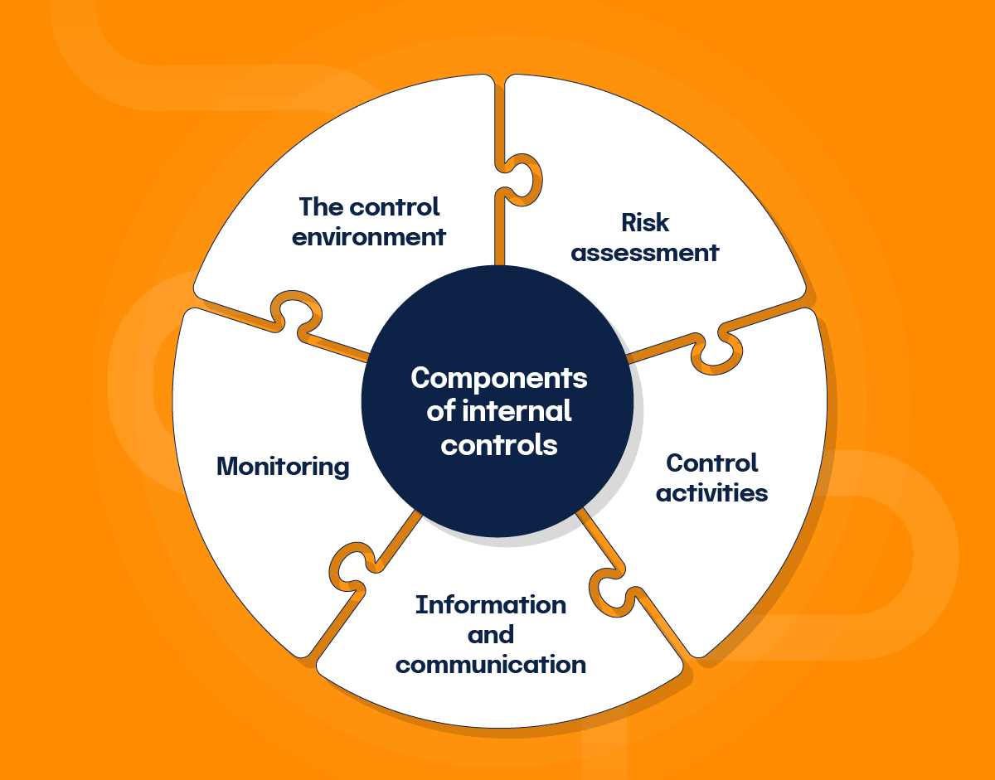

* **External Audit:** This type of audit verifies the accuracy and reliability of financial statements.

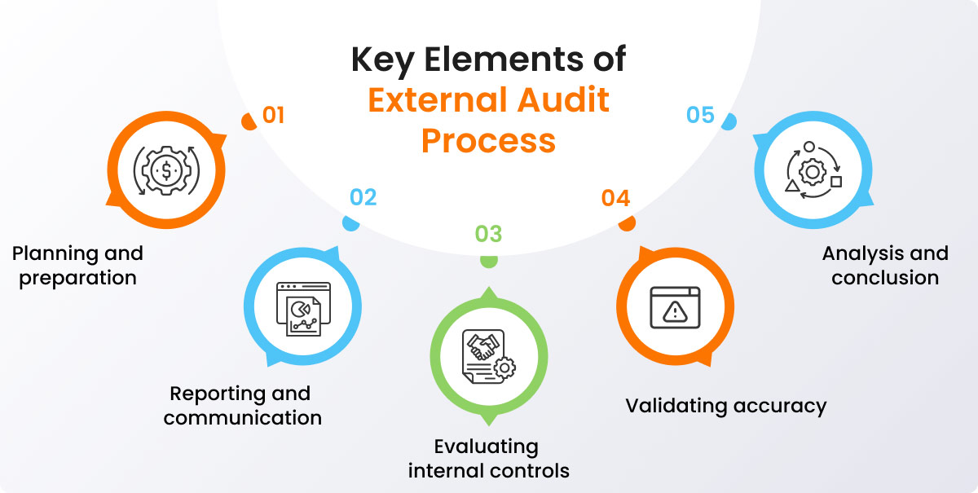

**1.5 IT AUDIT PROCESS:**

The IT audit process involves three main areas of investigation:

* **People:** The auditor needs to understand who has access to the system and data.
* **Processes:** Understanding how information flows through the company and what controls are in place to protect data.
* **Technology:** The auditor needs to understand the technologies in use, how they are configured, and how they interact with other systems.

## **2. Common Compliance Standards and Their IT Auditing Requirements:**

**2.1 ISO/IEC 27001**

ISO/IEC 27001 is a globally recognized standard that provides the framework for an information security management system (ISMS). IT audits for ISO/IEC 27001 focus on verifying whether the ISMS aligns with the standard’s requirements including,

* The assessment of risk management procedures
* The security controls
* The effectiveness of the organization’s policy for information security

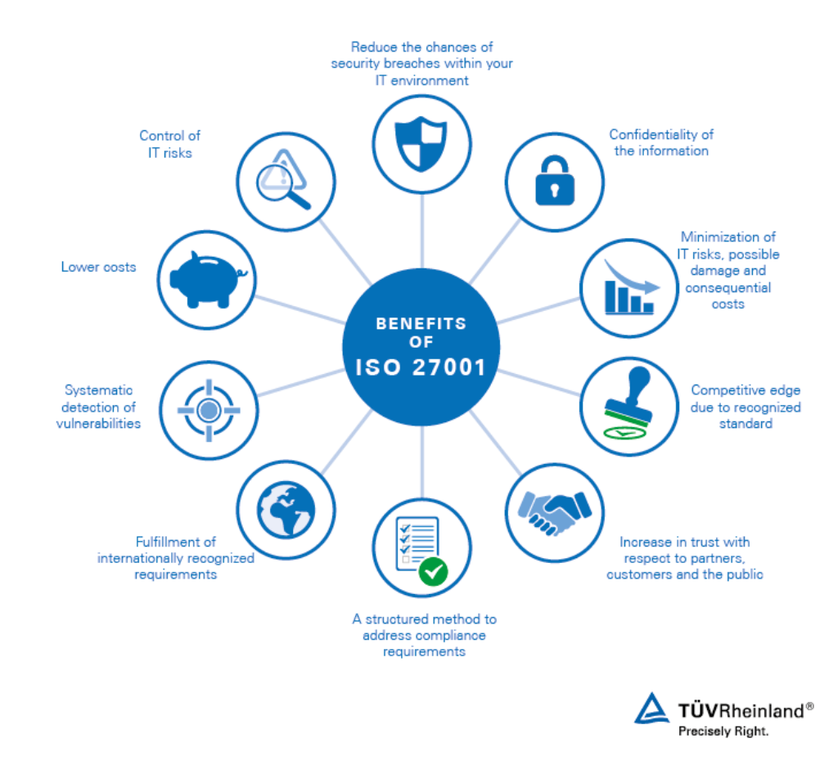

**2.2 PCI DSS**

IT audits for PCI DSS involve assessing the organization’s adherence to the standard’s requirements include,

* Protecting cardholder data
* Maintaining a vulnerability management program
* Implementing strong access control measures.

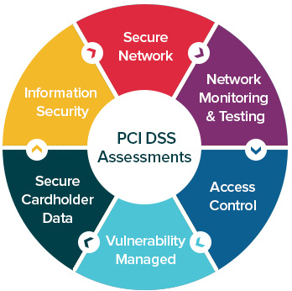

**2.3 COBIT**

Control Objectives for Information and Related Technologies (COBIT) is a voluntary framework for IT management and governance.

IT audits based on COBIT standards evaluate:

* The governance and management of enterprise IT environments
* Focusing on performance and risk management
* To ensure that IT processes support the organization’s strategic objectives.

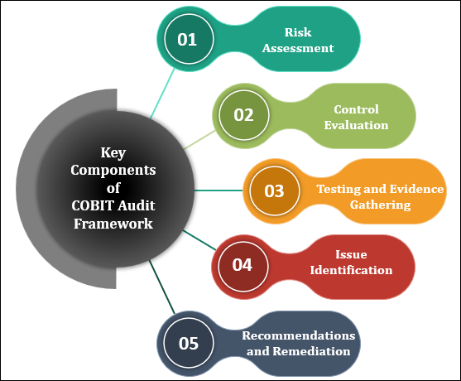

**3. CONCLUSION**

In conclusion, IT audit plays a crucial role in ensuring the security, reliability, and compliance of an organization's information systems. By following established guidelines and utilizing advanced technology, IT audit helps organizations mitigate risks and improve their overall performance.

|  |  |  |
| --- | --- | --- |
|  |  |  |
| Our greatest glory is not in never failing, but in rising every time we fail. - Confucius |
|  |